|  |  |
| --- | --- |
|  | part 2  web development  itani mulaudzi |

**SECTION A**

**Updates**

Background colour : blue

Some pictures are resized

Made the top taskbar to be at top right and the bottom one at the bottom left and wrote the name of the shop at top left and made the top taskbar to be responsive

Changed the colour of the logo to blue

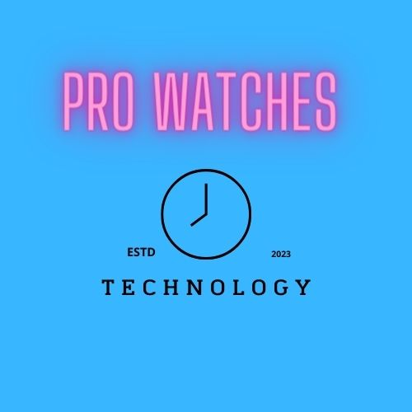

Changed the slogan font and made it bigger and changed its colour to purple

**Website assets updates**

**Homepage**

New Description :

PRO WATCHES brings you our exclusive range of affordable and beautiful watches .  
Packed with features offering unbeatable value ,  
our smart watches will keep you fit, fashionable and fabulous!

Placed the slogan under the logo and changed the colour of the font to blue

**About us**

Placed the slogan at the top and I’ve inserted a background photo for the main .The description is written in red and white and masked with a blue colour so that it can be easy to read

**Product and service**

also placed a logo and I’ve made all the buttons to be green and I’ve added some pictures and the background colour is blue

**Gallery**

Added some pictures of the watches

**Contact**

Added some pictures and made the text to be blue and also resized the google enquiry . changed the font of h3 and h2

**Added photos**

